

Lab #5 A* Search
Artificial Intelligence
SUBMITTED BY:
UBAID AHMAD
ROLL NO:
2410-0011
SUBMITTED TO:
Ma’am Wardah Asad
DATE:
13/03/2026

LAB TASK
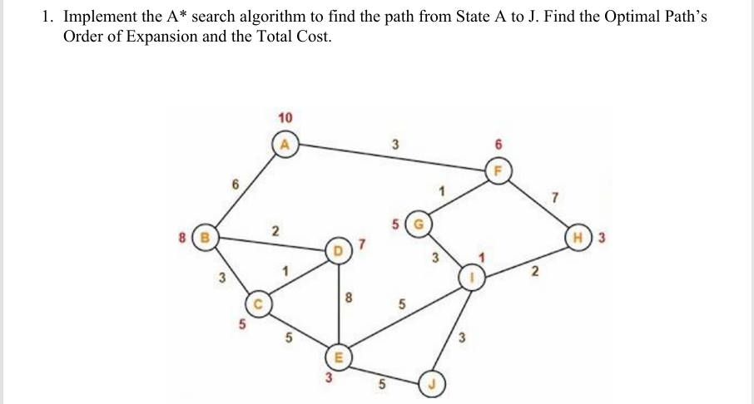
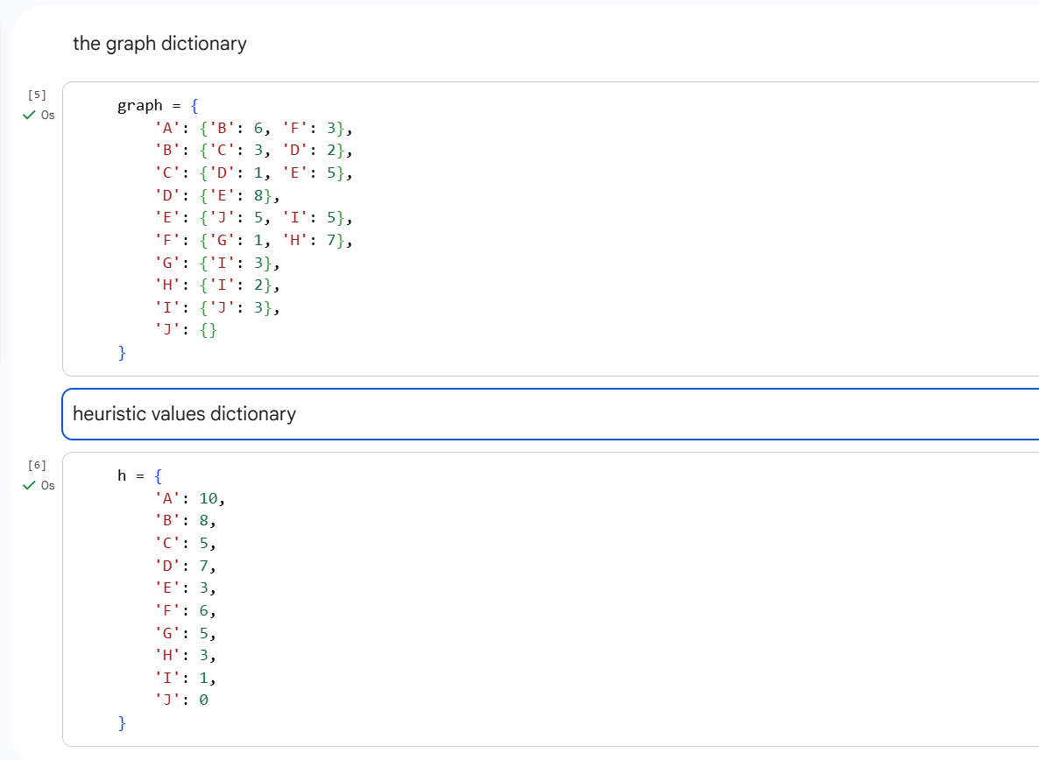
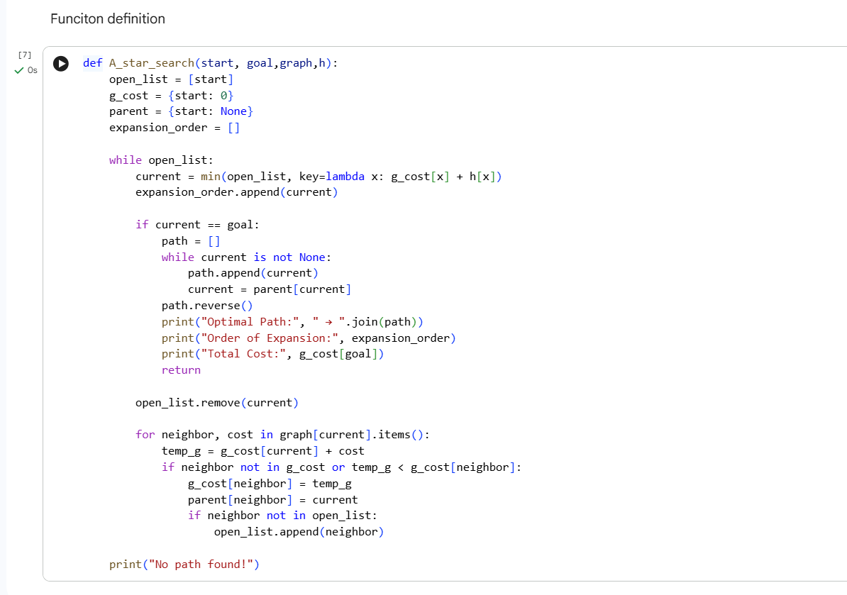
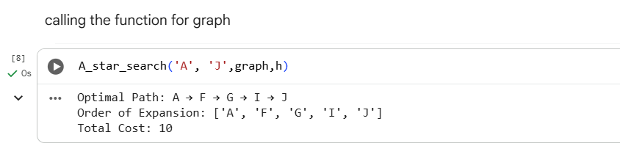

END,,,

